## **Course challenge**

1.

Question 1

Scenario 1, questions 1-5

You’ve just **started a job as a data analyst at a small software company that provides data analytics and business intelligence solutions.** Your supervisor asks you to kick off a project with a new client, Athena’s Story, a feminist bookstore. They have four existing locations, **and the fifth shop has just opened in your community.**

Athena’s Story wants to produce a campaign to generate excitement for an upcoming celebration and introduce the bookstore to the community. **They share some data with your team to help make the event as successful as possible.**

**Your task is to review the assignment and the available data, then present your approach to your supervisor.** Click the link below to access the email from your supervisor:

**https://d3c33hcgiwev3.cloudfront.net/TkP8IQ5xS2aD_CEOcQtmgw_176061a98c73468980b6d7241a16a62e_Course-2-Scenario-1-Email-from-Supervisor.pdf?Expires=1622678400&Signature=UqzZ6CKCHxD6UoxMv-OFmy9Ve0LxqbVXJrPQYmW~6mhVEru6IBH5ZeOmv3cxg-sPRUbzIELeKYTP2G5ebJmFBnUHTdXWkDcw5FaTsv-a715YN~kWfG9KbPB7xry-ihb6gpUCHB4apfv5hiKx2ApXdsaOwEfHNIKR6tQ-oZIIWBQ_&Key-Pair-Id=APKAJLTNE6QMUY6HBC5A**

Then, review the email, and review the Customer Survey and Historical Sales datasets:

From: Rosa <Manager@Analytics_Company.com>

Date: Mon, 1/9/2021 2:14 PM

Subject: Athena’s Story March campaign

To: Data Analyst <You@Analytics_Company.com

Good afternoon! See below for an exciting opportunity from our newest client, Athena’s Story, a feminist bookstore that just opened in our city. They’re looking for us to help them make their March campaign a success. I know you’ll do a great job supporting the launch of their new bookstore. Looking forward to hearing how you might tackle this challenge -- please reach out with any questions.

Rosa

---------- Forwarded message ---------

Hello, Rosa:

Thanks for the call yesterday! We’re looking forward to partnering with you on our upcoming WHM campaign. We’ve been excited to open our newest location in your community and are hoping that you can help us make this campaign a success. We’ve gathered results from a recent customer survey. **The survey includes data about whether people plan to celebrate WHM.** **It also asks if they might celebrate by purchasing feminist books as a gift for a friend or just to enjoy themselves.** **And we surveyed customers to find out what they like most about Athena's Story and what types of books they’d like us to carry in the future. We also have a dataset of historical data of internal sales records from our other four stores. We’ve included information on our two most profitable genres**: **feminist fiction and biographies of inspiring women.** And we’ve included information on two new genres: children’s literature and feminist zines. **We’ve only started carrying children’s literature and feminist zines in the past 12 months, but our customer survey does seem to indicate that people would enjoy seeing more of these kinds of titles.** As you know, we don’t have our own analytics or insights team, so we’re hoping you can help us make sense of it all. Let us know if we can answer any questions for you or your analytics team.

Thanks! Emmeline, on behalf of Athena’s Store

* You may click the link to create a copy of the dataset: [Customer Survey](https://docs.google.com/spreadsheets/d/1HbBfNTuHCmQyY0GJrsdj6OCOkmeA5sUAQ-jXx8bMdpY/template/preview) or CSV to download below
* [CustomerSurvey - CustomerSurvey.csv](https://d3c33hcgiwev3.cloudfront.net/OP-YnyENQQ2_mJ8hDZENcg_87992fc45aef4c4cbc4b77e0d52a220e_CustomerSurvey---CustomerSurvey.csv?Expires=1622678400&Signature=RGI-Rkj5pE9US8d99jpKNkAhT8FebehBzFL4s2akegu71pAR75R7RnrbnPQEtai3KZDvhGkngbatRjrB1qW25bJA~MKkageiSPAokZs4WP~1vShBruzcpsODS0FcwM6fWNSl1h3mDmUZwK~cRBXr9JOpxznDEvPYhjCEixqKlUY_&Key-Pair-Id=APKAJLTNE6QMUY6HBC5A)
* You may click the link to create a copy of the dataset [Historical Sales](https://docs.google.com/spreadsheets/d/1HO8B-svc3Mmm3hlWycvX61Boxl9RQv6nKKWnkRig83E/template/preview) or CSV to download below
* [HistoricalSales - HistoricalSales.csv](https://d3c33hcgiwev3.cloudfront.net/ta9P5mnbRZevT-Zp2wWXMw_dbd2edcd01804aa49f17fef80cc70f95_HistoricalSales---HistoricalSales.csv?Expires=1622678400&Signature=OSf3MXH-tvKwfROYGzigpvnbrRMmhoO1FN9tm3~Cxf2S8rJpj7Mz9t56RV7zoSknUd1JZof5eK77Yu4Ekq6QIHqdu491yXX~Atrr-FOCLOhdwvZaPFVDgYRRGCw0R9acCGcGtZo6syVIZORDJhRVRCFjTyO8reCHYCQRFUjIruQ_&Key-Pair-Id=APKAJLTNE6QMUY6HBC5A)

After reading the email, you notice that the acronym WHM appears in multiple places. You look it up online, and the most common result is web host manager. That doesn’t seem right to you, as it doesn’t fit the context of a feminist bookstore.

How do you proceed?

1 point

1. Call the client to ask what WHM means and inform them that using acronyms is not a professional business practice.
2. Schedule a meeting with your supervisor, the client, and another analyst on your team to figure out the meaning.
3. Proceed with the project assuming WHM must mean web host manager.
4. Send your supervisor a polite, concise email, asking them to confirm the meaning of WHM. yes this one

2. Question 2

Scenario 1 continued

Now that you know WHM stands for Women’s History Month, you continue reviewing the datasets. You notice the [Customer Survey](https://docs.google.com/spreadsheets/d/1HbBfNTuHCmQyY0GJrsdj6OCOkmeA5sUAQ-jXx8bMdpY/template/preview) (link to download CSV instead below) dataset contains both qualitative and quantitative data.

[CustomerSurvey - CustomerSurvey.csv](https://d3c33hcgiwev3.cloudfront.net/XWDVQrA7Tceg1UKwO93H_g_929b420254cb4ecbbb654c871375d673_CustomerSurvey---CustomerSurvey.csv?Expires=1622678400&Signature=Dvw5hTbTrSgxF02ymVjrGGZZtAAdWKE3z~f9B2rCyMeVtq24KaAbYQDu7L-TKj9TXSvoVubEAUnXt6aB1t9~y1ynoBScD8N-Sxss2-ldfJtYdKrbcybb4ypz6mRBS1XGGHJQwB92bcTFI-s9p3pvWarLLqqiNjwfAc7avcsQUSM_&Key-Pair-Id=APKAJLTNE6QMUY6HBC5A)

The quantitative data includes information from which columns? Select all that apply.

1 point

Column C (Survey Q3: Do you purchase feminist books in honor of WHM, either for yourself or as a gift for someone else?)

Column A (Survey Q1: Do you plan to celebrate WHM?)

Column E (Survey Q5: What do you like most about Athena's Story?)

Column D (Survey Q4: If answered "Yes" to Q3, how many books do you typically purchase during March?)

Question 3

Scenario 1 continued

3. Next, you review the customer feedback in column F of the [Customer Survey](https://docs.google.com/spreadsheets/d/1HbBfNTuHCmQyY0GJrsdj6OCOkmeA5sUAQ-jXx8bMdpY/template/preview) (link to download CSV instead below) dataset contains both qualitative and quantitative data.

[CustomerSurvey - CustomerSurvey.csv](https://d3c33hcgiwev3.cloudfront.net/XWDVQrA7Tceg1UKwO93H_g_929b420254cb4ecbbb654c871375d673_CustomerSurvey---CustomerSurvey.csv?Expires=1622678400&Signature=Dvw5hTbTrSgxF02ymVjrGGZZtAAdWKE3z~f9B2rCyMeVtq24KaAbYQDu7L-TKj9TXSvoVubEAUnXt6aB1t9~y1ynoBScD8N-Sxss2-ldfJtYdKrbcybb4ypz6mRBS1XGGHJQwB92bcTFI-s9p3pvWarLLqqiNjwfAc7avcsQUSM_&Key-Pair-Id=APKAJLTNE6QMUY6HBC5A)

The attribute of column F is, “Survey Q6: What types of books would you like to see more of at Athena's Story?” In order to verify that children’s literature and feminist zines are among the most popular genres, you create a visualization. This will help you clearly identify which genres are most likely to sell well during the Women’s History Month campaign.

Your visualization looks like this:

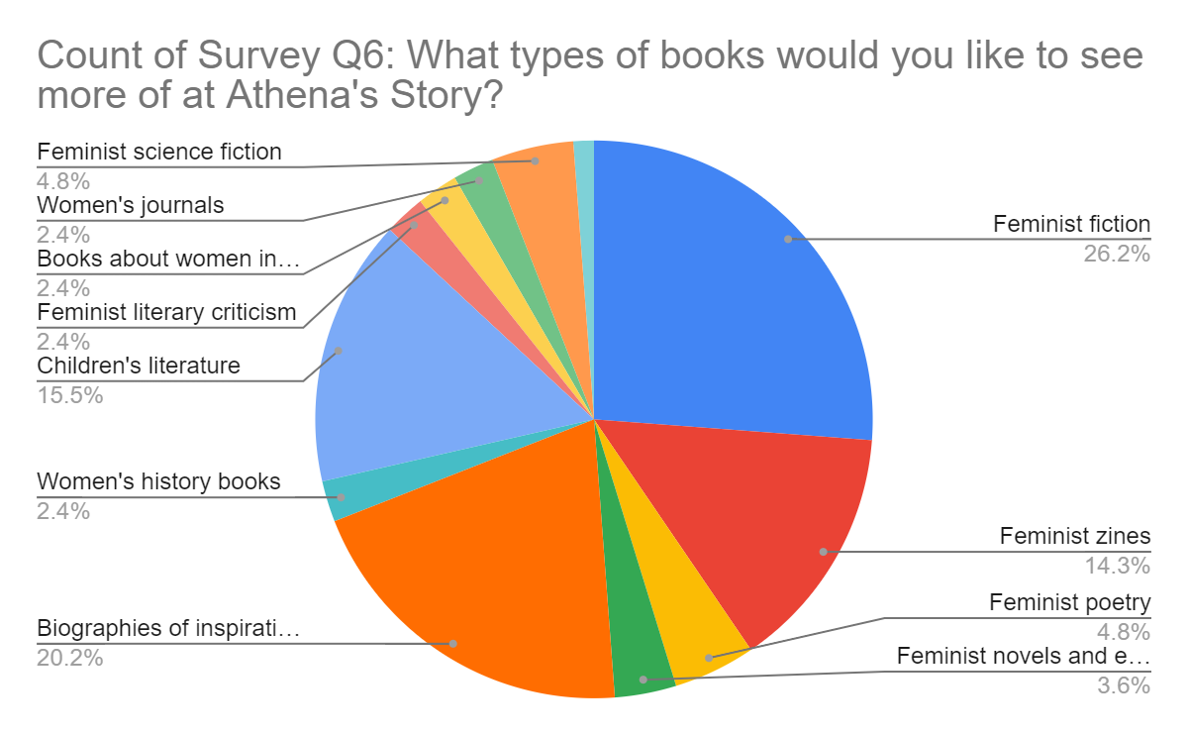

What is a pie chart effective for demonstrating?

1 point

1. Where things are located on a map
2. Trends over time
3. Percentages that make up a whole
4. Relationships between variables

4. Now that you’ve confirmed that children’s literature and feminist zines are among the most requested book genres, you review the [Historical Sales](https://docs.google.com/spreadsheets/d/1HO8B-svc3Mmm3hlWycvX61Boxl9RQv6nKKWnkRig83E/template/preview).

If you do not have a Google account, download the CSV file below:

[HistoricalSales - HistoricalSales.csv](https://d3c33hcgiwev3.cloudfront.net/ta9P5mnbRZevT-Zp2wWXMw_dbd2edcd01804aa49f17fef80cc70f95_HistoricalSales---HistoricalSales.csv?Expires=1622678400&Signature=OSf3MXH-tvKwfROYGzigpvnbrRMmhoO1FN9tm3~Cxf2S8rJpj7Mz9t56RV7zoSknUd1JZof5eK77Yu4Ekq6QIHqdu491yXX~Atrr-FOCLOhdwvZaPFVDgYRRGCw0R9acCGcGtZo6syVIZORDJhRVRCFjTyO8reCHYCQRFUjIruQ_&Key-Pair-Id=APKAJLTNE6QMUY6HBC5A)

You’re pleased to see that the dataset contains data that’s specific to children’s literature and feminist zines. This will provide you with the information you need to make data-inspired decisions. In addition, the children’s literature and feminist zines metrics will help you organize and analyze the data about each genre in order to determine if they’re likely to be profitable.

Next, you calculate the total sales over 52 weeks for feminist zines. What is the correct syntax?

1 point

1. =CALCULATE(E2:E53)
2. =COUNT(E2:E53)
3. =MAX(E2:E53)
4. =SUM(E2:E53)

5.

Question 5

Scenario 1 continued

After familiarizing yourself with the project and available data, you present your approach to your supervisor. You provide a scope of work, which includes important details, a schedule, and information on how you plan to prepare and validate the data. You also share some of your initial results and the pie chart you created.

**In addition, you identify the problem type, or domain, for the data analysis project.** You decide that the historical sales data can be used to provide insights into the types of books that will sell best during Women’s History Month this coming year. This will also enable you to determine if Athena’s Story should begin selling more children’s literature and feminist zines.

Question 6

Scenario 2, questions 6-10

You’ve completed this program and are now interviewing for your first junior data analyst position. You’re hoping to be hired by an event planning company, Patel Events Plus. Access the job description below:

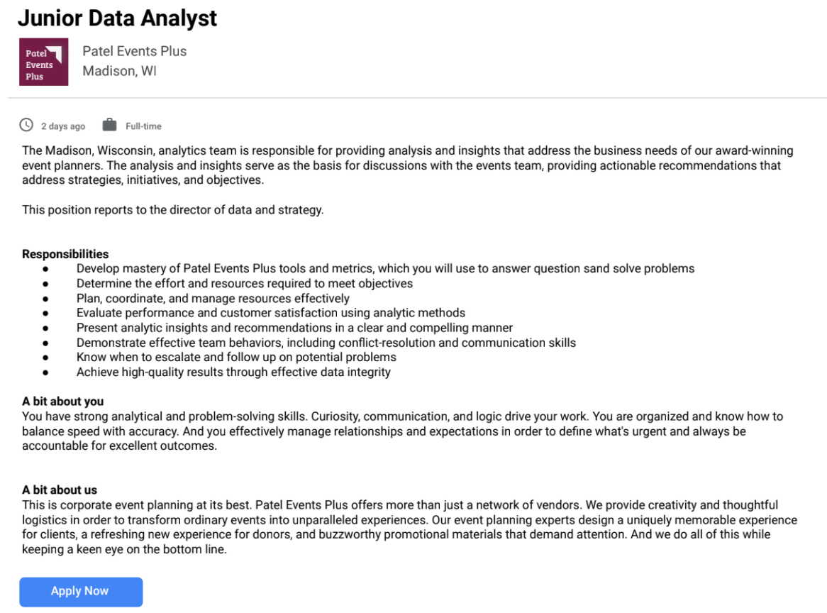

So far, you’ve successfully completed the first round of interviews with the human resources manager and director of data and strategy. Now, the vice president of data and strategy wants to learn more about your approach to managing projects and clients. Access the email you receive from the human resources director below:

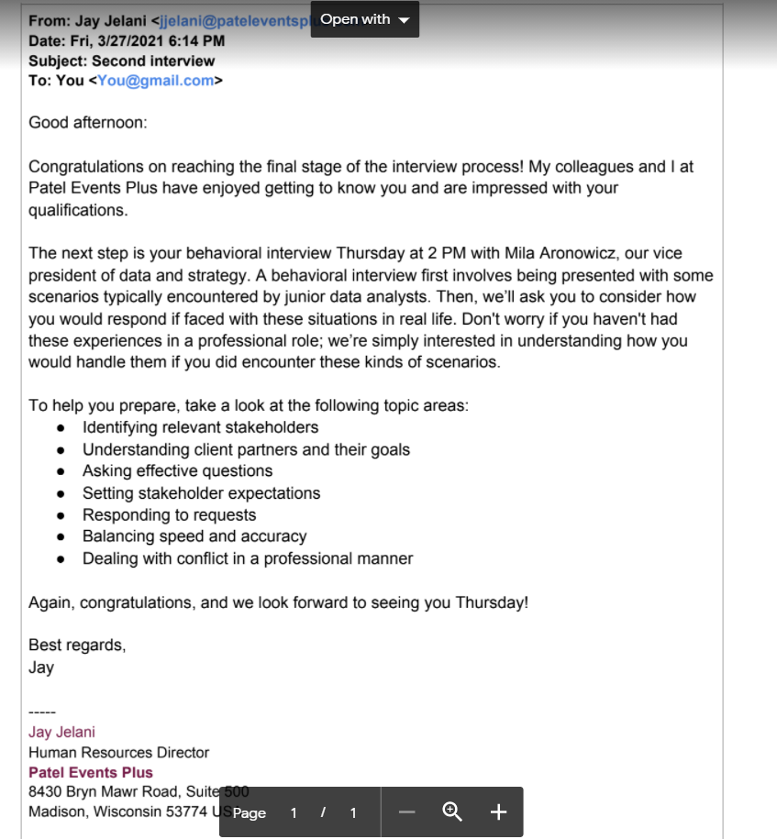

You arrive Thursday at 1:45 PM for your 2 PM interview. Soon, you’re taken into the office of Mila Aronowicz, vice president of data and strategy. After welcoming you, she begins the behavioral interview.

First, she hands you a copy of Patel Events Plus’s organizational chart. Access the chart below:

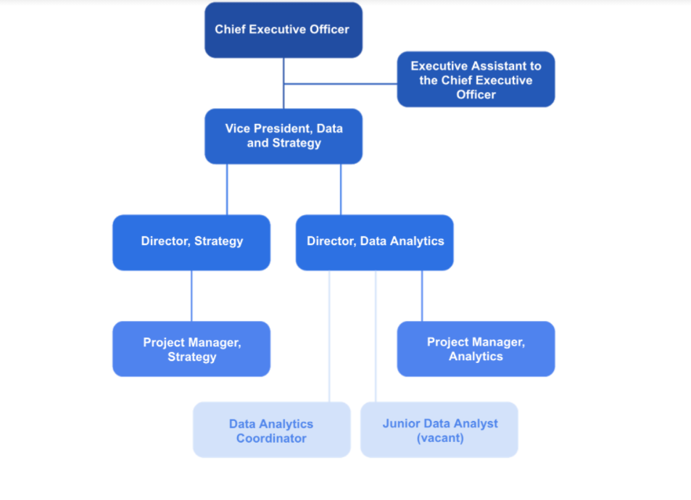

As you’ve learned in this course, stakeholders are people who invest time, interest, and resources into the projects you’ll be working on as a data analyst. Let’s say you’re working on a project involving data and strategy. Based on what you find in the organizational chart, if you need information from the primary stakeholder, who can you ask?

1 point

Vice president, data and strategy

Director, strategy

Chief executive officer

Project manager, analytics

7.

Question 7

Scenario 2 continued

Next, the vice president wants to understand your knowledge about asking effective questions. Consider and respond to the following question. Select all that apply.

Let’s say we just completed a big event for a client and wanted to find out if they were satisfied with their experience. Provide some examples of measurable questions that you could include in the customer feedback survey.

1 point

How would you describe your event experience?

On a scale from 1 to 5, with 1 being not at all likely and 5 being very likely, how likely are you to recommend Patel Events Plus?

Would you recommend Patel Events Plus to a colleague or friend? Yes or no?

Why did you enjoy the event planned by Patel Events Plus?

8.

Question 8

Scenario 2 continued

Now, the vice president presents a situation having to do with resolving challenges and meeting stakeholder expectations. Consider and respond to the following question.

You’re working on a rush project, and you discover your dataset is not clean. Even though it has numerous nulls, redundant data, and other issues, the primary stakeholder insists that you move ahead and use it anyway. The project timeline is so tight that there simply isn’t enough time for cleaning. How would you handle that situation?

1 point

Clean the data as quickly as you can. It’s not perfect, but it’s better than it was before, and this way you can meet the deadline.

Contact the stakeholder’s boss to let them know about the issue and ask for help managing the stakeholder’s expectations.

Communicate the situation to your supervisor and ask for advice on how to handle the situation with the stakeholder.

The stakeholder is in charge. It's best to do as they say and use the unclean dataset.

9.

Question 9

Scenario 2 continued

Your next interview question deals with sharing information with stakeholders. Consider and respond to the following question. Select all that apply.

Let’s say you’ve created a report to present stakeholders with information about an upcoming event. Describe the benefits of using a report.

1 point

Reports enable stakeholders to interact with the data.

Reports reflect data that’s already been cleaned and sorted.

Reports offer live monitoring of incoming data.

Reports provide a snapshot of high-level, historical data.

10.

Question 10

Scenario 2 continued

Your final behavioral interview question involves using metrics to answer business questions. Your interviewer hands you a copy of [PatelEventsData](https://docs.google.com/spreadsheets/d/1mHgcNViGB2wm8cxz0ZrrxWm1VvNxeqlfAuA3bd_aE6s/template/preview) (link to download as CSV below instead).

[Patel Events Plus dataset.csv](https://d3c33hcgiwev3.cloudfront.net/H0ow0rvpTW2KMNK76W1taQ_1f687892bdc64c83bfba59f168c7a41e_Patel-Events-Plus-dataset.csv?Expires=1622678400&Signature=MaqFDM0UE38G9O7j1o~eLSqGPmowHSt8gTMOo8AbmrifQswL7zZm9vYW~6ZX2IWOybSFDsB5XB~gQAF3~Gqxy18AnVuqOPhz4INyk8hOG3LFZjcUiLJMuN-h2asv4KAUUiMYDeKGEmoUv7DfMnrP2WiJboGdlu0Y2yhRWwxxk40_&Key-Pair-Id=APKAJLTNE6QMUY6HBC5A)

Then, she asks: Recently, Patel Events Plus purchased a new venue for our events. If we asked you to calculate the return on investment of this purchase, the metrics to consider would be the cost of the investment and what else?

1 point

Purchase date

Average event revenues

2019 events held at new venue

Net profit in 2019